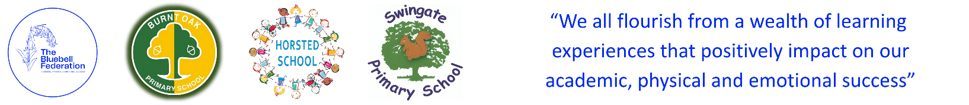

The Bluebell Federation Meeting Attendance 2025/2026

 |  | 25/09/2025 | 20/11/2025 | 22/01/2026 | 12/03/2026 | 21/05/2026 | 16/07/2026
Tara Baker
Darren Bird
Stacey Brooker |  |  | x
David Coates |  |  | x |  | x
Steve Geary
Barry Hammond
Amanda Howes |  | x
Paul Harrison (Vice Chair)
Simon Lucas |  | x |  | x | x
Stephen Roe
Terry Smith (Chair)

